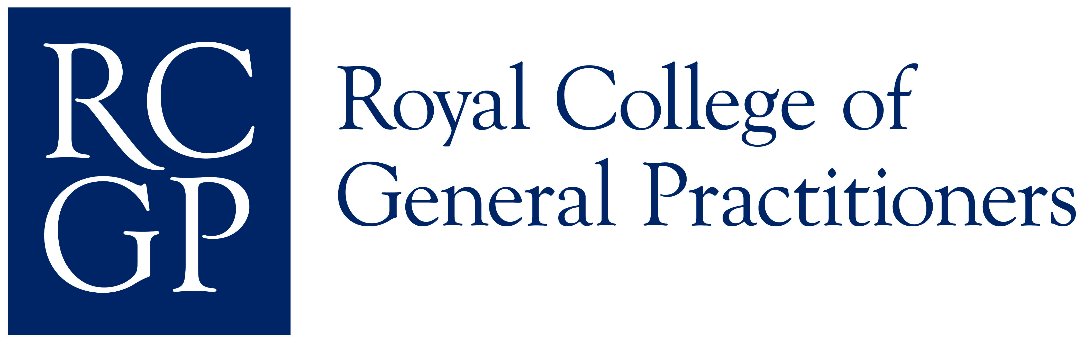

Introduction to Clinical Examination and Procedural Skills Assessment (Integrated DOPS)

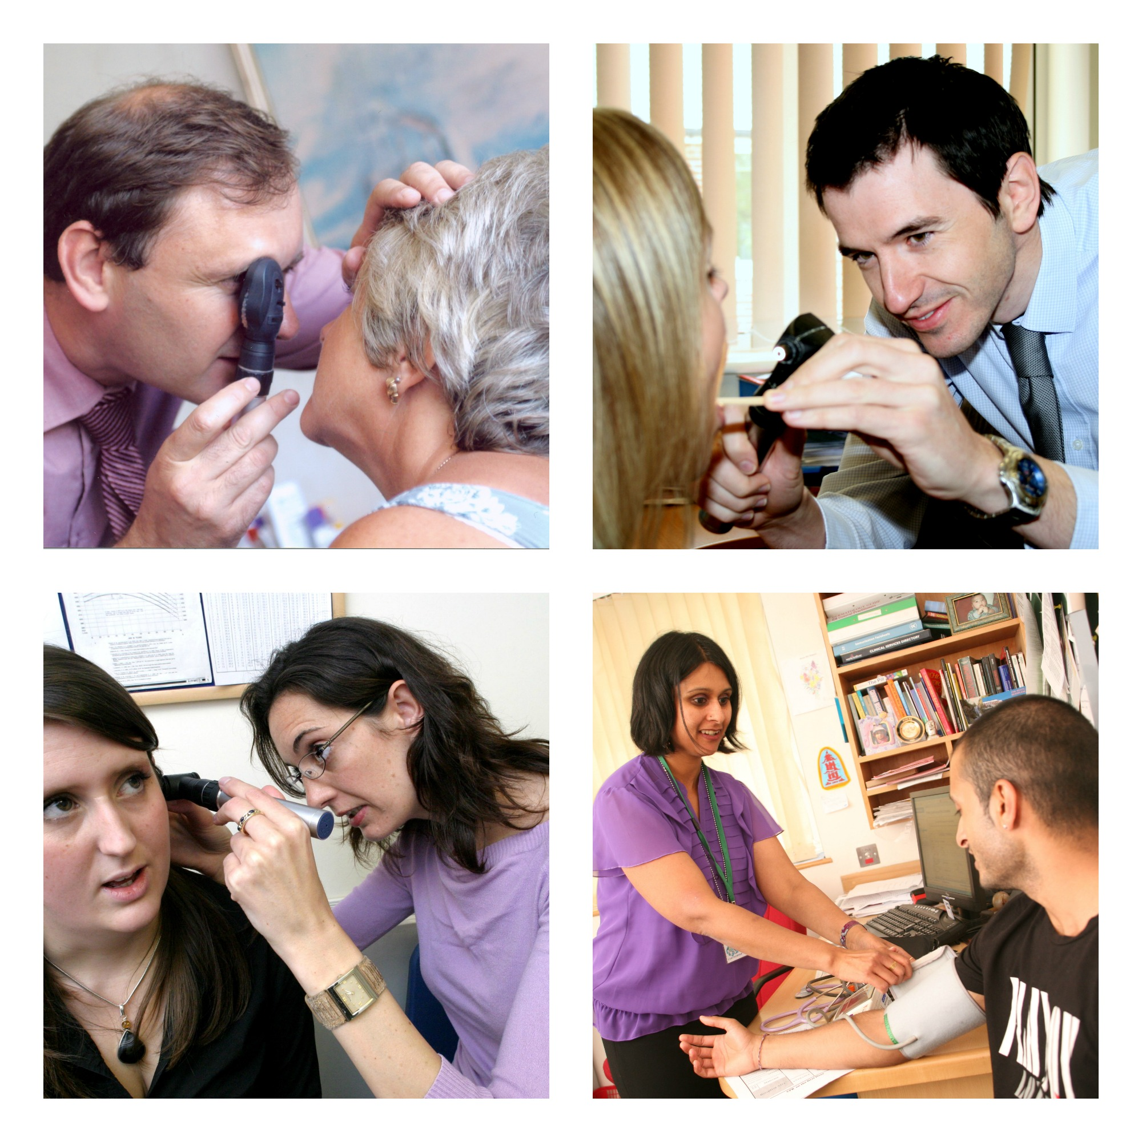

October 2014
RCGP WPBA core group

Contents

Introduction 3

Summary of the key changes 4

Step-by-step guide for Trainees 6

Step-by-step guide for Educational Supervisors 9

Appendix A: Word pictures and IPUs 11

Appendix B: Examination and Procedural skills descriptors 13

Appendix C: ESR questions – Clinical Examination and Procedural Skills 16

Appendix D: Changes to COT criteria and MSF 17

Appendix E: Learning log entry 18

Appendix F: Clinical Examination and Procedural Skills evidence form 20

Introduction to Clinical Examination and Procedural Skills

The assessment of clinical examination and procedural skills is an extremely important part of GP training. Competence in these skills is integral to the provision of good clinical practice. As a trainee, you will have a range of clinical skills at the time of recruitment to the GP specialty-training programme. You are expected to demonstrate progress in applying these skills in the GP workplace during your training and also within the CSA. When you complete training, you must be competent to apply your skills unsupervised however complex the clinical context might be.

From August 2015, there will no longer be a prescribed list of clinical examinations or procedural skills, which must be demonstrated, although it will remain essential to show evidence of competence in breast examination and in the full range of male and female genital examinations as this is required by the GMC.

Similarly, there will be no minimum number of assessments to be recorded. Instead, you will be expected to discuss your learning needs during placement planning meetings and to record your plans in the learning log and PDP. The range of examinations and procedures and the number of observations will depend on the needs of the trainee and the professional judgment of the educational supervisor.

By making these changes, we aim to give you more professional responsibility for directing your learning and extra flexibility to focus on the areas where you need to further develop your examination skills.

We wish you the best of luck with your training!

The Workplace Based Assessment Team

Summary of the key changes

‘Clinical examination and procedural skills’ will become a new additional competence to be completed by trainees and supervisors in the Educational Supervisor's review. It will appear as a new category within the ePortfolio learning log that you can tag relevant activities and experience against.

The new competence will feature in the Educational Supervisor's Report (ESR) in the same way that the other 12 currently appear and will be placed after the Data-gathering and Interpretation competence, within the diagnostics section.

Within this document is the word picture (Appendix A), which describes the various grades for this new competence. Indicators of potential underperformance, which are currently listed below the word picture in Appendix A, will be included within the word picture when released within the ePortfolio.

Clinical examination and procedural skills are intricately linked to many of the existing competences and detailed descriptors of how these fit into the existing competences are explained (Appendix B).

In addition there will be three new questions for the ES to rate progress specifically in this area, these questions (which will eventually replace the current skills section) will appear after the competences and will focus on breast examination and the full range of male and female genital examination (Appendix C).

The CSR currently includes a section relating to history taking, examination and investigations; this will be separated into 2 sections, one for history taking and the other for examinations.

The wording of the COT and the MSF will change slightly to reference clinical examination and procedural skills (Appendix D).

A new type of log entry will be available to help the trainee record their learning and skill acquisition related to clinical examination and procedural skills (Appendix E). It will remain the responsibility of the trainee to gather evidence for this competence as it is with the original 12.

What type of learning events can be used as evidence for this competence area?
- COT / miniCEX
- Direct observation of examination or procedure alone
- CbDs
- Random case review
- Surgery debriefs
- Joint surgeries
- Referrals analysis including correspondence back from secondary care
- Simulation stations
- Other assessor feedback
- MSF

None of these in isolation will provide sufficient evidence and this is not an exhaustive list of evidence that can be used.

An optional specific feedback form will replace the formal DOPS assessment form and allow formative feedback on examination and procedural skills (Appendix F).

There may be occasional circumstances where you are unable to perform a clinical examination or procedural skill yourself due to a physical disability. In these situations you will be assessed in your competence in being able to identify the examination required, recognising and reflecting in your learning log that you are unable to do this yourself and ensuring the patient has timely access to another competent health professional to undertake the procedure.

The transition period

We are hopeful that we will gain GMC approval for the new system to replace the mandatory list of DOPS that is currently required for WPBA from August 2015. From November 2014, the two systems will run in parallel so that the GMC can be sure that a satisfactory assessment of examination and procedural skills is being carried out and that the new proposed system is in fact better than the one in place at present.

All trainees completing their training before August 2015 will need to carry on completing the mandatory DOPS as these will still be needed for your Certificate of Completion of Training (CCT).

Trainees who finish training after August 2015 and have completed any of the current mandatory DOPS will not have wasted any effort as these completed mandatory DOPS will contribute to supporting your overall competence in clinical examination and procedural skills within the new system.

Step-by-step guide for Trainees
You should complete clinical examination and procedural skills as opportunities arise during training. Evidence for this will occur regularly during consultations and joint surgeries. It is expected that your supervisors will also observe you performing clinical examination and procedural skills and this can be documented within the log.
How to record evidence of Clinical Examination and Procedural Skills (Integrated DOPs) within your ePortfolio
You should document clinical examinations and procedural skills within your learning log. As with all log entries these will need to be linked to the relevant curriculum heading and will need to include a range of entries from specific areas, for example cardiovascular/ respiratory / children / elderly and patients with Mental Health problems. Log entries will require reflection on any communication, cultural or ethical difficulties encountered.
Observation and assessment of clinical examination and procedural skills may be made by clinical supervisors and other colleagues (including senior nurses and trainees more senior than ST4). Observation forms can be downloaded from the ePortfolio.
The log will also ask specifically if the examination was a genital or intimate examination as there has been concern that these would otherwise not be done.
Your Educational Supervisor can validate your log entries against the competence areas once you share these entries with them.
Evidence of Progression of Clinical Examination and Procedural Skills (Integrated DOPS)
Trainees and Educational Supervisors (ES) will be required to comment on evidence of progression in examination and procedural skills within the six monthly Educational Supervisor's Report (ESR). This will occur within the trainee’s and ES’s assessment of the competences. A trainee will need to show that they are competent for licensing in clinical examinations and procedural skills to obtain their Certificate of Completion of training.

The ES will also be asked three questions within the skills log section of the review. In particular the ES will be required to comment on your skills in conducting breast examination and the full range of female and male genital examinations.

It is the responsibility of trainees and their trainers to ensure that there is sufficient evidence of competence recorded in the ePortfolio.

Learning logs:
- A new type of learning log will allow you to record learning and skill acquisition relating to a new competence in ‘clinical examination and procedural skills.’
- Use the word pictures for the new Competence to describe your learning in this area and if it is relevant your ES will validate it to the new competence heading.
- As with all log entries you may link to the relevant curriculum headings and you will need to include a range of entries from specific areas, for example cardiovascular/ respiratory / children / elderly and patients with Mental Health problems.
- It is essential that you include breast examinations and the full range of female and male genital examinations
- Log entries will require you to reflect on any communication, cultural or ethical difficulties encountered.

ESR preparation and self rating:
- You will need to provide enough evidence for your supervisor to link to the clinical examination and procedural skills competence as you do with the other competences. It remains your responsibility to obtain sufficient evidence to demonstrate satisfactory progress in this area.
- You will need to state how the evidence you have provided supports your personal assessment of your progress using the word pictures for this competence to aid you. A range of attributes is required for you to demonstrate progress in this competence as detailed in the word pictures.
- You can use a variety of sources of evidence (log entries, MSF, COTs and clinical examination and procedural skills evidence forms).
- Your ES will be asked the following three questions so you will need to ensure your evidence sufficiently covers these,
1. Are there any concerns about the trainee’s clinical examination or procedural skills? If the answer is, “yes” please expand on the concerns and give an outline of a plan to rectify the issues.
2. What evidence of progress is there in the conduct of genital and other intimate examinations (at this stage of training), with reference to any previous reviews? Please refer to specific evidence since the last review including Learning Log entries, COTs and CBDs etc.
3. What does the trainee now need to do to improve their clinical examination and procedural skills?

PDP:
- You should consider including specific PDP entries to meet specific learning needs in examination and procedural skills as well as other learning needs.

Other changes:
- The MSF will have an additional line requesting feedback on examination and procedural skills in the clinical assessment section.
- COT wording will be changed to specifically allow feedback on examination and any procedural skills observed during this assessment.
- An additional electronic form will be available to record any clinical examination and procedural skills observed by other team members. This will allow formative feedback.
Step-by-step guide for Educational Supervisors

Learning logs:
A new type of learning log will allow recording of learning and skill acquisition in clinical examination and procedural skills. Use this as evidence and comment on it in the same way as with the existing 12 competences.
- Use the word pictures for the new competence to decide if the log shows learning in this area and if it does, validate it by linking to the new competence heading. Use the comments box to provide positive feedback on what the trainee has achieved.
- If you do not think it should be validated explain why and what additional evidence would be appropriate.
- Challenge the trainee and stretch then by making suggestions for further development.

ESR:
Approach this competence in the same way as the other 12.
- Read, evaluate and make a judgement on all the available evidence relating to this competence in the MSF, CSR, COTS and learning logs in the same way as the other 12.
- In the agreed actions sections describe how the trainee should develop in this area before the next review.

In addition you as the ES will be asked to comment on three questions relating to clinical examination and procedural skills.
1. Are there any concerns about the trainee’s clinical examination or procedural skills? If the answer is, “yes” please expand on the concerns and give an outline of a plan to rectify the issues.
2. What evidence of progress is there in the conduct of genital and other intimate examinations (at this stage of training), with reference to any previous reviews? Please refer to specific evidence since the last review including Learning Log entries, COTs and CBDs etc.
3. What does the trainee now need to do to improve their clinical examination and procedural skills?

Other changes:
- The MSF will have an additional line requesting feedback on examination and procedural skills in the clinical assessment section.
- COT wording will be changed to specifically allow feedback on examination and any procedural skills observed during this assessment.
- An additional electronic form will be available to record any Clinical Examination and Procedural Skills observed by other team members and will allow formative feedback (Appendix F).

Appendices

A Word pictures for Clinical Examination and Procedural Skills competence

B Examination and Procedural skills descriptors

C Changes to ES questions asked at end of skills log

D Changes to COT (criterion6) and MSF wording

E Learning log and trainee guidance to completing log

F Clinical Examination and Procedural skills evidence form for assessors

Appendix A

Word pictures and IPUs for clinical examination and procedural skills

Clinical Examination and Procedural Skills
This competence is about clinical examination and procedural skills and by the end of training, the trainee must have demonstrated competence in Breast examination and in the full range of male and female genital examination
Insufficient Evidence | Needs Further Development | Competent | Excellent
From the available evidence, the doctor’s performance cannot be placed on a higher point of this developmental scale | Chooses examinations broadly in line with the patient’s problem(s) | Chooses examinations appropriately targeted to the patient’s problem(s) | Proficiently identifies and performs the scope of examination necessary to investigate the patient’s problem(s)
 | Identifies abnormal signs but fails to recognise their significance | Has a systematic approach to clinical examination and able to interpret physical signs accurately | Uses an incremental approach to examination, basing further examinations on what is known already and is later discovered
 | Suggests appropriate procedures related to the patient’s problem(s) | Varies options of procedures according to circumstances and the preferences of the patient | Demonstrates a wide range of procedural skills to a high standard
 | Demonstrates limited fine motor skills when carrying out simple procedures | Refers on appropriately when a procedure is outside their level of skill | Actively promotes safe practice with regard to examination and procedural skills
 | Observes the professional codes of practice including the use of chaperones | Identifies and discusses ethical issues with regard to examination and procedural skills | Engages with audit quality improvement initiatives with regard to examination and procedural skills
 | Performs procedures and examinations with the patient’s consent and with a clinically justifiable reason to do so | Shows awareness of the medico-legal background to informed consent, mental capacity and the best interests of the patient | Helps to develop systems that reduce risk in clinical examination and procedural skills
 | The intimate examination is conducted in a way that does not allow a full assessment by inspection or palpation. The doctor proceeds without due attention to the patient’s perspective and feelings | Ensures that the patient understands the purpose of an intimate examination, describes what will happen and explains the role of the chaperone. Arranges the place of examination to give the patient privacy and to respect their dignity.  Inspection and palpation is appropriate and clinically effective. | Recognises the verbal and non-verbal clues that the patient is not comfortable with an intrusion into their personal space especially the prospect or conduct of intimate examinations. Is able to help the patient to accept and feel safe during the examination.

Indicators of potential underperformance (IPU):
- Fails to examine when the history suggests conditions that might be confirmed or excluded by examination
- Patient appears unnecessarily upset by the examination
- Inappropriate over - examination
- Fails to obtain informed consent for the procedure
- Patient shows no understanding as to the purpose of examination.

Appendix B

Examination and Procedural Skills descriptors

These descriptors are for the guidance of Trainees and their Clinical and Educational Supervisors. They may be read in conjunction with the descriptors for rating the assessment of competence.

Communication and consultation skills
- Explores the patient’s previous experience of the examination/procedure should they have any.
- Explains the process, and purpose for the examination/procedure in language that is easily understood by the patient.
- Ensures that the process, and purpose for the examination/procedure is understood and gains consent to proceed.
- Offers the attendance of a chaperone when this is appropriate for either doctor or patient.
- Doctor is sensitive to the patient’s situation and perspective and seeks throughout to ensure the patient is happy for them to continue.
- Communicates effectively throughout the procedure putting the patient at ease.
- Ensures any discomfort is kept to the minimum. Checks with the patient that they are happy for them to continue, should any discomfort occur.
- Explains the findings to the patient in appropriate manner after completing the procedure. Maintains the dignity of the patient and incorporates the patient’s beliefs when appropriate.
- Responds to verbal and non-verbal cues from the patient.
- Seeks to confirm the patient’s understanding of the findings or consequences of the examination or procedure.
- Explains when results of such procedure will be available and arranges appropriate follow up.

Practising holistically
- Demonstrates an understanding of the patient’s wishes in relation to their cultural or religious background relevant to the examination or procedure. Takes appropriate steps to adhere to any adjustments that are feasible.

Data gathering and interpretation
- Chooses examinations and procedures appropriately which are relevant to the patient’s presenting complaint or situation.
- Identifies abnormalities when they are present and finds examination normal when they are absent.
- Recognises the implications of examination findings.
- Extends the examination or procedure when the findings dictate.

Making a diagnosis
- Interprets findings to aid diagnosis using patterns of recognition.
- Revising hypotheses in the light of additional information.

Clinical management
- Refers on appropriately when the procedure is outside their level of skill and experience or when the examination findings indicate the need for referral.

Managing medical complexity
- Interprets the effect of long standing findings related to pre-existing conditions and differentiates these from findings related to an acute problem.
- Is able to tolerate uncertainty resulting from the findings or outcome of the examination or procedure.
- Communicates the risk of the procedure to the patient and involves them in the decision making.
- Monitors the patient’s progress for any adverse outcomes and minimises risk by appropriate safety netting.

Primary care administration and information management and technology
- Records accurately their examination findings in the primary care IMT system, including the patient’s consent in a manner that is coherent and comprehensible.
- May audit an aspect of procedural skills using the computer records.

Working with colleagues and in teams
- When a procedure or examination involves other members of the team, works co-operatively with the other member and uses their skills appropriately.
- Communicates effectively with the team member to enhance patient care.

Community orientation
- Optimises the use of limited resources through cost effective use of all necessary equipment and other resources.

Maintaining performance learning and teaching
- Shows a commitment to professional development through reflection on performance of procedural skills and the identification of and attention to learning needs.
- Evaluates the process of learning to make future learning cycles more effective.
- Participates in audit where appropriate and uses audit activity on procedural skills to evaluate and suggest improvements in personal and practice performance.
- Identifies learning objectives related to procedural skills and uses teaching methods appropriate to these.
- Assists in making assessments of learners’ procedural skills when their own level of experience makes shared assessment appropriate.

Maintaining an ethical approach
- Is aware of their own limitations and does not attempt procedures for which they are not qualified.
- Seeks helps when needed.
- Does not perform procedures without the patient’s consent or without a clinically justifiable reason to do so.

Fitness to practice
- Observes the accepted codes of practice in order ensure patient safety. This includes clear documentation of the patient’s consent, the offer of a chaperone and the appropriateness of the procedure related to the patient’s complaint.

Appendix C

ESR questions – Clinical Examination and Procedural Skills

Three ESR questions to be located where ES currently rates progress on careS and skills logs

Three ESR questions to be located towards the end of the ES review

1. Are there any concerns about the trainee’s clinical examination or procedural skills? If the answer is, “yes” please expand on the concerns and give an outline of a plan to rectify the issues.
2. What evidence of progress is there in the conduct of genital and other intimate examinations (at this stage of training), with reference to any previous reviews? Please refer to specific evidence since the last review including Learning Log entries, COTs and CBDs etc.
3. What does the trainee now need to do to improve their clinical examination and procedural skills?

Appendix D

Changes to COT criteria

COT criteria 6
This competence will be about both the appropriate choice of examination, and performance of examination when directly observed. A mental state examination would be appropriate in a number of cases. Intimate examination should not be recorded (on video), but directly observed.

Multisource feedback change

The questions asked in the MSF are unaltered.
Part 2 of the MSF asks the assessor to make a comment on the Doctors overall clinical performance.
The prompts given in this section which help the assessor reach their decision will be changed to the following;
‘You may wish to comment on the doctor’s ability to:
- Conduct a thorough history
- Identify a patients’ problems
- Make a diagnosis
- Perform a range of clinical, procedural and technical skills effectively
- Manage patients
- Learn from their clinical experience
- Manage time appropriately’

Appendix E

Learning log entry

Type: Clinical Examination and Procedural skills

Date: *…………………………..

Curriculum linkage:…………….

Clinical Examination or Procedural Skill performed,
(Please be specific, for example prostate examination not just rectal examination or cranial nerve examination not just neurological examination)

If observed, state name of observer and position

Observer………….
Position ………….

Reason for physical examination, procedure performed and physical signs elicited (to include whether this was the expected finding)

Reflect on any communication or cultural factors

Reflect on any ethical factors (to include consent)

Self assessment of performance (to include overall ability and confidence in this type of examination or procedure)

Learning needs identified

How and when these learning needs will be addressed

Trainee Guidance for completing the learning log ‘clinical examination and procedural skills’

Include entries to demonstrate your ability to perform clinical examinations and procedures against the curriculum areas.

Suitable examinations will include cardiovascular, respiratory, neurological, abdominal, musculoskeletal and mental state examinations.

Cases should also include examinations of different patient groups, i.e. elderly and paediatric patients

Ensure you have linked the entry to the relevant curriculum area.

It is essential within your learning log to include evidence of competence in breast examination and in the full range of male and female genital examinations, as there is concern that these may otherwise not be done. Your Educational Supervisor can complete a Clinical examination and Procedural Skills evidence form if they/you feel this is necessary.

When completing the log entry you need to consider any communication, ethical or cultural issues, for example the use of chaperones or when it was felt to be inappropriate to examine and why.

When appropriate your ES will then be able to validate this entry against the competence for clinical examination and procedural skills. They may make a comment in the usual way which highlights any areas of concern, or areas of particular strengths, etc.

Appendix F
Clinical Examination and Procedural Skills evidence form (Integrated DOPS)

Trainees name to be automatically populated
Assessor
Drs Surname

Drs Forename

GMC number

Free text

Clinical examination / Procedural skill observed

What was performed well? To consider:
- Communication with patient
- Awareness of cultural and ethical factors
- Ability to perform clinical examination or procedural skill
- Consideration of patient and professionalism demonstrated

Areas for further development

